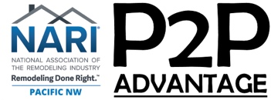

Roles of P2P Advantage Members

- Moderator – The moderator is responsible for the group development over the course of his/her team. It is critical that the moderator has an agenda and reviews it with the group in advance. Not having a written agenda can be frustrating because it does not allow others to have input and it does not let others know when a given topic will be covered or when a given discussion will end. This can create a feeling of uncertainty and unease. It is therefore critical to share the agenda in the beginning and ask whether anyone has any input on it. The moderator should also review the constitution periodically so that it is not lost and forgotten. The moderator needs to report any member additions or resignations to the P2P program manager. Another important role of the moderator is to ensure that there is a presenter for each meeting.

- Back-up Moderator – This person serves as moderator when moderator presents or when moderator is absent.

- Secretary – The secretary is responsible for the administrative matters of the group including, keeping attendance and tardiness records, keeping minutes of the business portion of meeting, and handling communications if necessary.

- Timekeeper – The most important thing is to give warnings and signal when time is up. It is up to the moderator to extend the time. That allows the group to be aware of what to expect rather than just being frustrated as a result of the ambiguity.

- Speech Monitor – Person who monitors Language Protocol. This is especially important for new groups. It lays a solid foundation for the group’s growth.

